SIMATS ENGINEERING
ASSESSMENT TOOL 2

COURSE NAME: Database Management Systems
COURSE CODE: CSA05

COURSE OUTCOME COVERED

CO2: Apply the relational model, relational algebra, SQL query structures, and views to solve database querying and data manipulation problems. (BL3, BL6)

Activity Tool : Scenario-Based Task (Medium)
Assessment Tool Weightage: 20%

QUESTIONS
Q.No | Question | Bloom's Level
1 | A university stores student and course data in a single table. Analyze the structure and identify normalization issues, then redesign it up to 3NF | . BL4 – Analyze
2 | A company database contains employee and department details. Design appropriate SQL queries to retrieve employees working in multiple departments and justify your approach | . BL6 – Create
3 | Given a relation with multiple functional dependencies, determine the candidate keys and check whether the relation satisfies BCNF. If not, decompose it. | BL5 – Evaluate
4 | A banking system requires secure data access. Design views and constraints to ensure data security and integrity for different types of users. | BL6 – Create
5 | A sales database contains redundant data leading to anomalies. Analyze the schema and apply normalization up to 3NF or BCNF to eliminate redundancy. | BL4 – Analyze
6 | Given a dataset of customers and orders, write SQL queries using joins and subqueries to retrieve meaningful information such as frequent customers. | BL3 – Apply
7 | A relation contains multi-valued dependencies. Analyze the structure and decompose it into 4NF, explaining the reasoning. | BL4 – Analyze
8 | A database designer used improper constraints, leading to inconsistent data. Evaluate the schema and suggest appropriate integrity constraints. | BL5 – Evaluate
9 | For a given relational schema, analyze the presence of join dependencies and decompose it into 5NF to remove redundancy. | BL6 – Create
10 | A system uses inefficient SQL queries for data retrieval. Analyze the queries and optimize them using joins, indexing concepts, or query restructuring. | BL5 – Evaluate

Code of Conduct:

I Subashree.N-192521377 (Name / Reg No) certify that this submission is my original work and that I have adhered to the guidelines specified for this assessment.
I understand that any violation of academic integrity rules will result in disciplinary action.

Signature of the student:
Subashree.N

RUBRICS FOR CALCULATION:

Criteria | Level 4 (Exemplary) | Level 3 (Proficient) | Level 2 (Developing) | Level 1 (Beginning)
Understanding of Scenario | Demonstrates clear and complete understanding of the scenario and context | Shows good understanding with minor gaps | Partial understanding; misses key aspects | Misinterprets or fails to understand the scenario
Identification of Key Issues | Accurately identifies all relevant issues and factors involved | Identifies most key issues with minor omissions | Identifies limited issues; some irrelevant points | Unable to identify key issues
Application of Concepts | Applies appropriate concepts effectively to address the scenario | Applies concepts with minor errors | Limited or partially correct application | Unable to apply relevant concepts
Decision Making | Makes well-reasoned, logical decisions with strong rationale | Makes reasonable decisions with some justification | Makes weak decisions with limited justification | No clear decisions made or rationale provided
Clarity of Response | Response is clear, structured, and logically presented | Generally clear with minor issues | Somewhat unclear or poorly structured | Disorganized and difficult to understand

1.University Database – Normalization (Up to 3NF)

EXPLAINATION:
The university stores student and course details in a single table, which can cause data redundancy and inconsistency. The table should be analyzed to identify normalization problems. It can then be divided into smaller related tables by applying 1NF, 2NF, and
3NF. This reduces duplicate data and avoids insertion, update, and deletion anomalies.

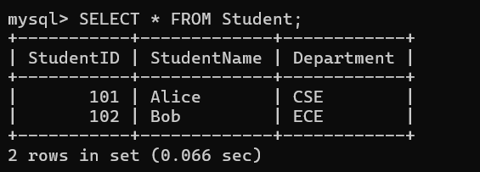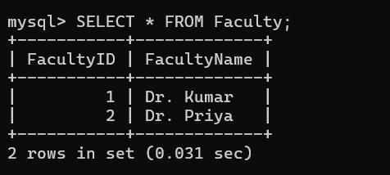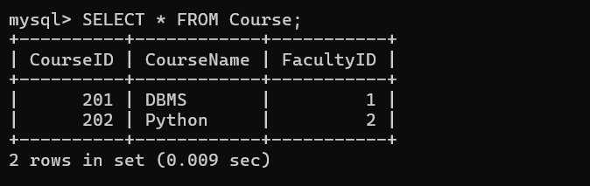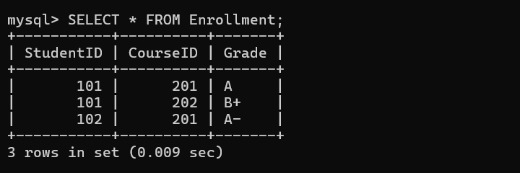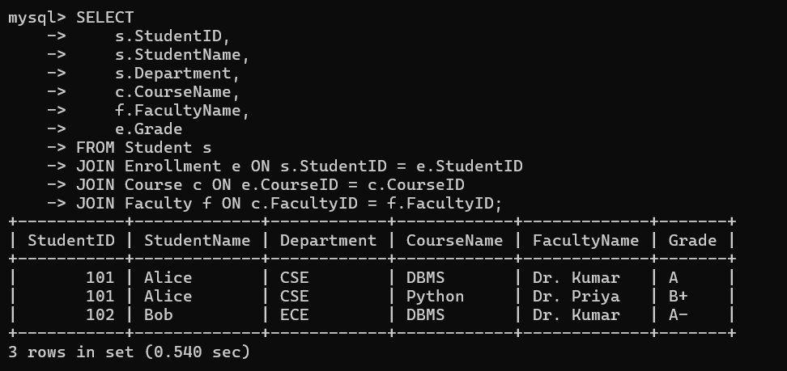

2.Employees working in multiple departments

EXPLAINATION:

The company database contains employee and department information. SQL JOIN queries can be used to connect employees with their departments. GROUP BY and HAVING can help identify employees working in multiple departments. This approach provides the required employee and department details accurately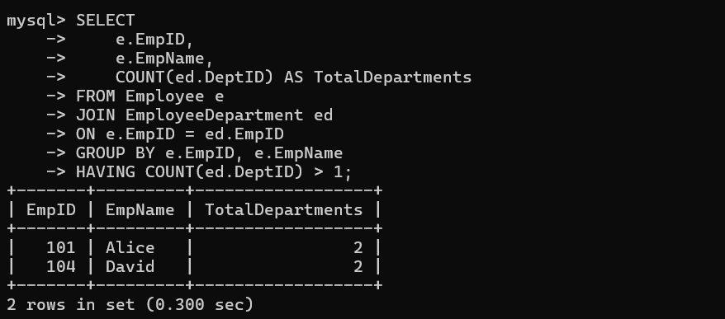
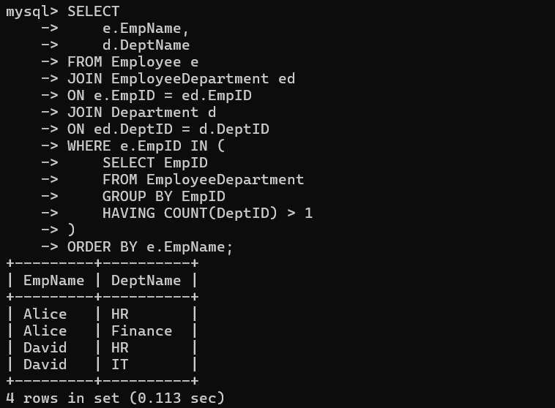

3.BCNF Decomposition

EXPLAINATION:

The given relation contains multiple functional dependencies that must be analyzed. Candidate keys are identified using these functional dependencies, and the relation is checked for BCNF. If a determinant is not a super key, the relation violates BCNF. In that case, the relation is decomposed into smaller relations to satisfy BCNF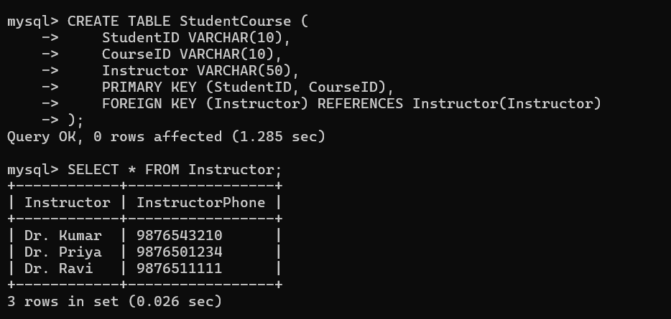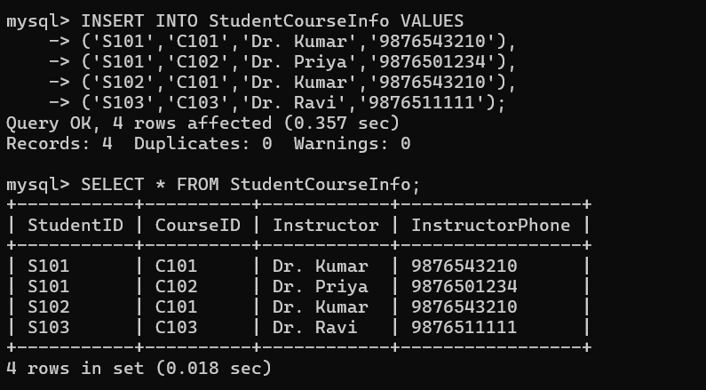
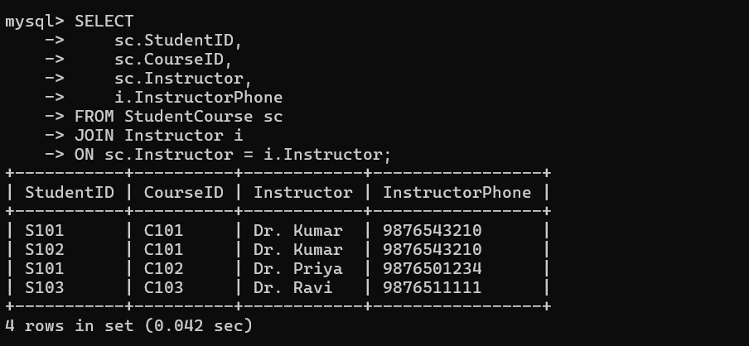

4.Banking System – Views and Constraints

EXPLAINATION:
A banking database requires secure access for different types of users. Views can be created to provide users with only the information they are allowed to access. Constraints such as primary key, foreign key, unique, and check constraints can maintain data integrity. This helps protect sensitive data and prevent invalid information

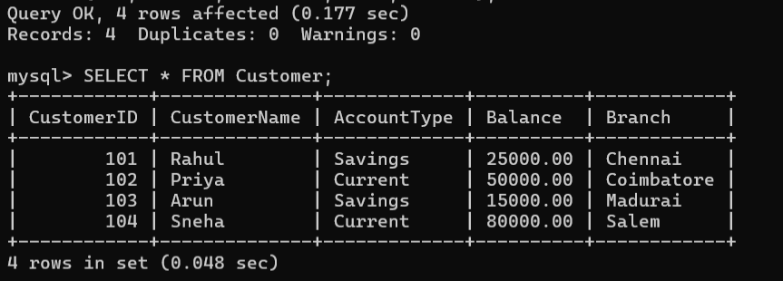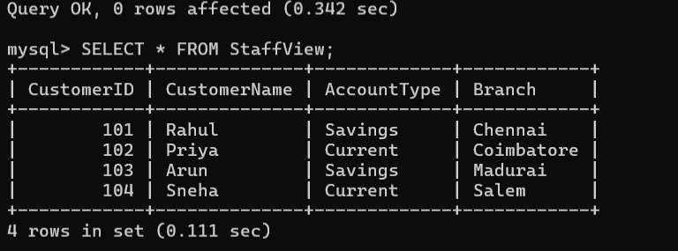
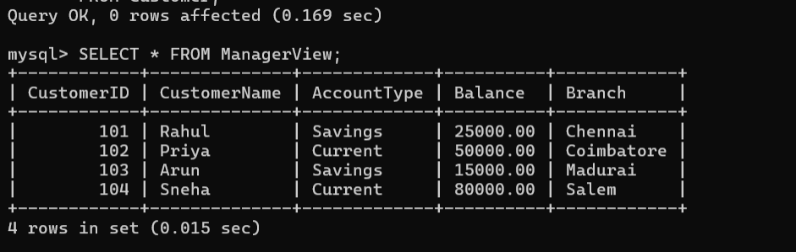

5.Sales Database – Normalization (3NF)

EXPLAINATION:

The sales database contains redundant data, which can lead to different types of anomalies. The existing schema should be analyzed to identify repeated and unnecessary information. Normalization can then be applied up to 3NF or BCNF to organize the data properly. This helps eliminate redundancy and improve data consistency
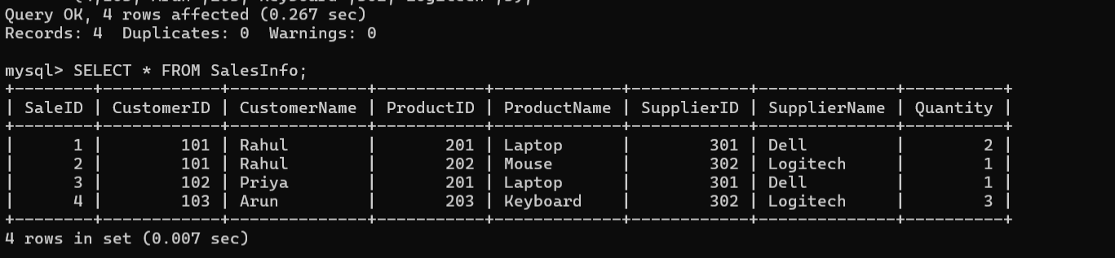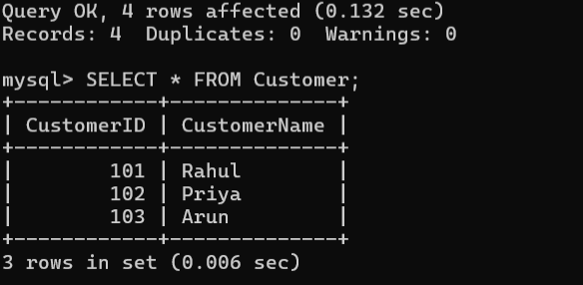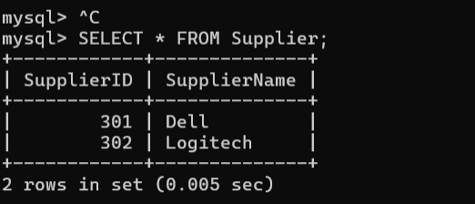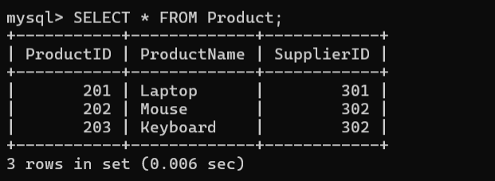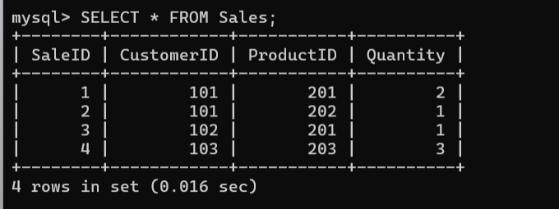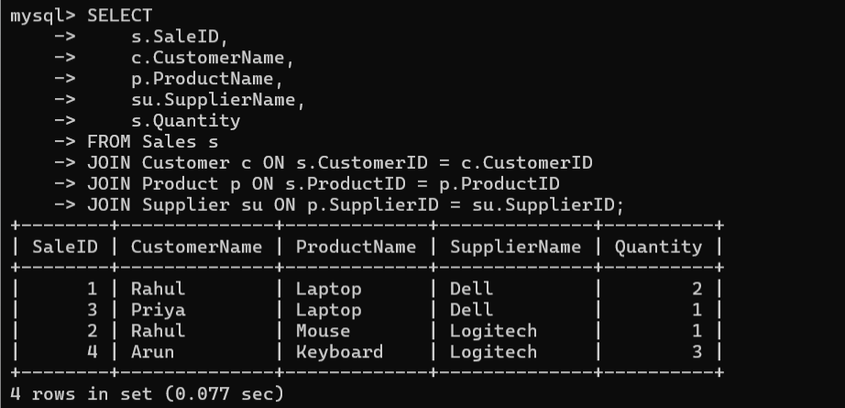

6.Customers and Orders – Joins & Subqueries

EXPLAINATION:

The customer and order tables can be connected using SQL JOIN operations. Subqueries can be used to retrieve specific information from the related tables. For example, frequent customers can be identified based on the number of orders they have placed. These queries help retrieve useful information from the customer and order database.
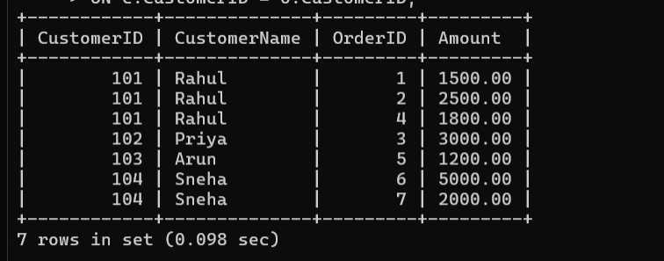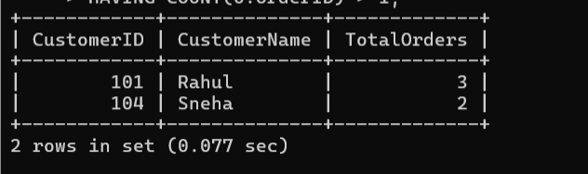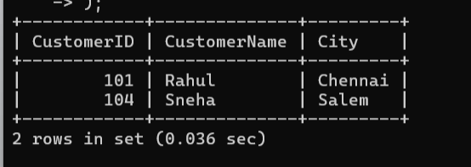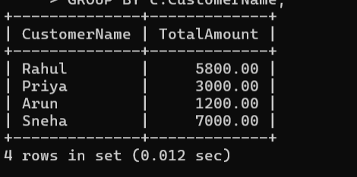

7.Multi-Valued Dependencies – Decompose into 4NF

EXPLAINATION:

The relation contains multi-valued dependencies that may cause unnecessary repetition of data. The dependencies should be analyzed to identify whether the relation violates 4NF. The relation can then be decomposed into smaller independent relations. This decomposition removes redundancy caused by multi-valued dependencies.
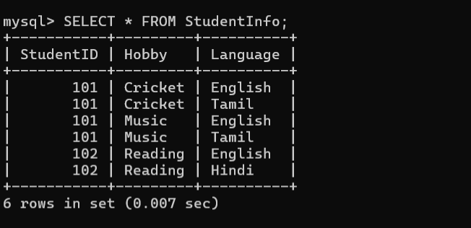
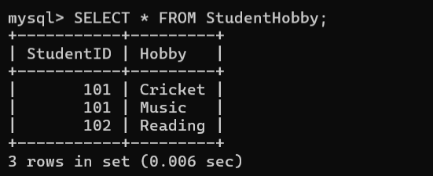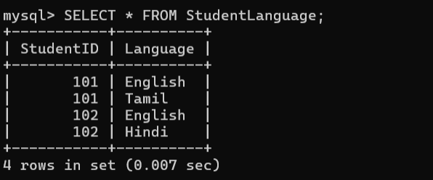

8.Integrity Constraints – Evaluate Schema

EXPLAINATION:

Improper constraints in a database can result in inconsistent or invalid data. The schema should be evaluated to identify missing or incorrect integrity constraints. Appropriate constraints such as primary key, foreign key, unique, and check can be applied. These constraints ensure that the stored data remains accurate and consistent.

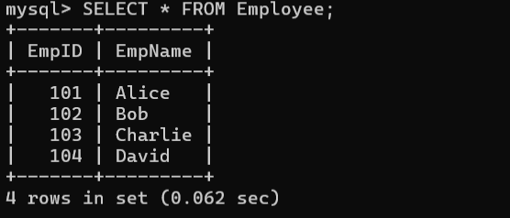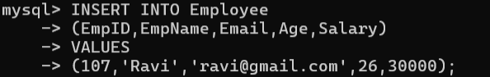

9.Join Dependencies – Decompose into 5NF

EXPLAINATION:

The relational schema should be analyzed to identify the presence of join dependencies. If join dependencies create redundancy, the relation needs to be decomposed into smaller relations. The decomposition should preserve the required relationships between the data. This process helps achieve 5NF and removes unnecessary redundancy
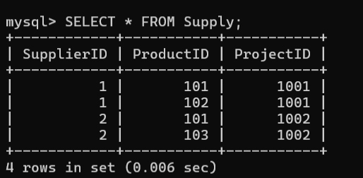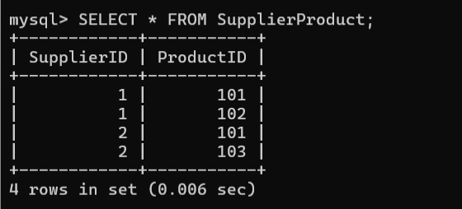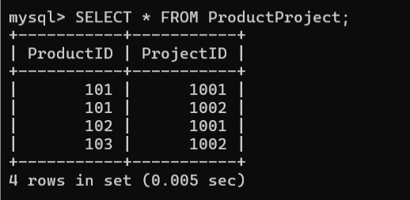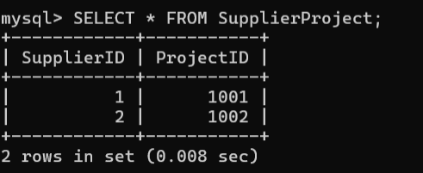

10.Optimize SQL Queries

EXPLAINATION:

Inefficient SQL queries can take more time and resources during data retrieval. The queries should be analyzed to identify unnecessary operations or poor query structures. Joins, indexing concepts, and query restructuring can be used to improve performance. Optimization makes the queries faster and more efficient.

